Fast Protein Folding in the Hydrophobic-hydrophilic Model
William E. Hart and Sorin Istrail
Proc. of 27th Annual ACM Symposium on Theory of Computation
Abstract
We present performance-guaranteed approximation algorithms for the protein folding problem in the hydrophobic-hydrophilic model.
- Introduction
- The Hydrophobic-hydrophilic Model
- Guaranteed Performance for Approximation Algorithms
Two types of performance guarantees are often described for approximation algorithm: the absolute performance ratio and the asymptotic performance ratio.
A(s) – the energy of the conformation generated for protein instance s by algorithm A
OPT(s) -- the energy of the optimal conformation
The absolute performance ratio R_{A}=sup{r1| R_{A}(s)r,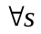} where R_{A}(s)= A(s)/ OPT(s)
The asymptotic performance ratio 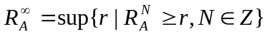where 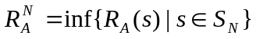
- Structure Analysis
  - Decomposition
We can decompose s into Z₀I₁Z₁…Z_{k-1}I_{k}Z_{k}, where Zi are sequence of 0’s and Ii are sequences of 1’s.
An instance s can also be decomposed into a sequence of blocks. A block b_{i} has the form b_{i}=1 or b_{i}=1Z_{i1}1…Z_{ih}1, where the Z_{ij} are odd-length sequence of 0’s and h>1.
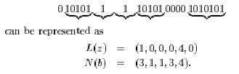
It is useful to divide blocks into categories: x-blocks and y-blocks.
For example, let x_{i}=b_{2i} and y_{i}=b_{2i-1}
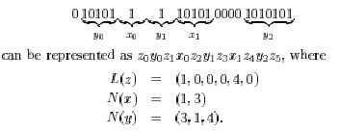
  - The Normal Form
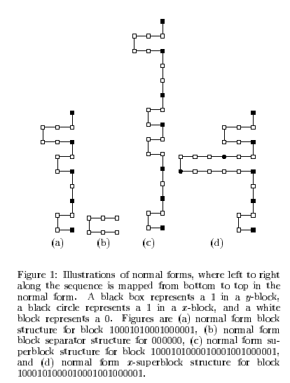

- Folding Sequences in the Two-Dimensional Model
  - Bound on the Optimal
We consider a lower bound on the energy of the optimal conformation.
OPT-2X-Tx(s)
  - Basic Approximation Algorithm
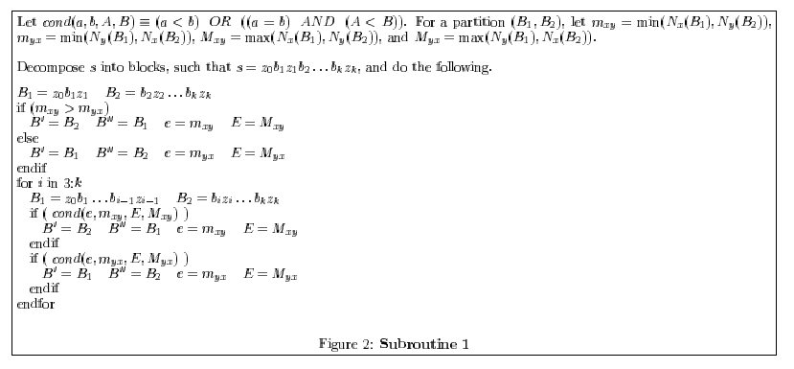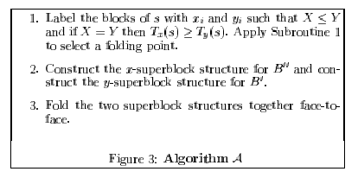
- Discussion
Created by: Yi-Yin Chen
Date: Oct. 30, 2001

